Technical Methodological Project: Integrated Multi-Source Demographic Monitoring System

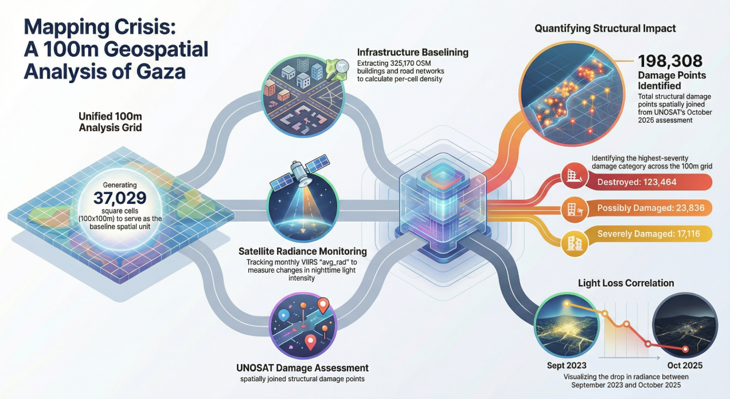

1. Strategic Framework for High-Resolution Population Estimation
In the complex operational environment of the Gaza Strip, traditional demographic monitoring has been rendered obsolete by the intersection of extreme urban density and unprecedented infrastructure destruction. Historical census data no longer reflects the ground reality, and physical surveys are frequently hindered by security constraints. To bridge this intelligence gap, we have developed a hybrid "structural-dynamic" monitoring framework. This approach moves beyond static counting, establishing a baseline of physical capacity and overlaying it with near-real-time signals of human activity.
The primary objective of this project is the creation of a high-resolution demographic surface at a 100x100m resolution. This granularity is essential for humanitarian actors to move beyond district-level aggregates and identify localized pockets of vulnerability. The methodology rests on three strategic pillars:
- Spatial Foundation: The construction of a standardized analytical grid to serve as the common denominator for data fusion.
- Structural Capacity Analysis: Quantifying the built environment—including building footprints and road accessibility—to determine the physical limits of human occupancy.
- Dynamic Presence Calibration: Integrating indirect and active signals, such as night-time lights and mobile network data, to track displacement patterns regardless of structural integrity.

2. The Spatial Foundation: 100-Meter Analytical Grid Construction
The prerequisite for multi-source data fusion is a standardized spatial container. A 100m square grid provides the optimal "middle ground" for analysis, balancing the high resolution of satellite building footprints (sub-meter) with the coarser spatial footprints of cellular tower signaling. This grid ensures that disparate data points—damage assessments, radiance values, and building counts—align perfectly for multivariate modeling.

Technical Specification of the Grid (EPSG:32636)
The grid is constructed using the WGS84 / UTM zone 36N projected coordinate system (EPSG:32636) to maintain metric accuracy across all distance and area calculations. To ensure the grid remains stable across different processing iterations, the origin is snapped to 100m increments using a specific logic: the origin_x and origin_y are calculated from the floor of the bounding box origin of the Area of Interest (AOI).
Parameter | Specification
Coordinate Reference System | WGS84 / UTM zone 36N (EPSG:32636)
Cell Geometry | 100m x 100m squares (10,000 m²)
Alignment Logic | Snapped to 100m increments (floor of bbox origin)
Output Attributes | cell_id, x_m/y_m (centroids), xmin_m, ymin_m, xmax_m, ymax_m
This systematic approach resulted in a validated framework consisting of exactly 37,029 cells for the Gaza AOI. During the construction process, cells are kept as full squares (not clipped) where they intersect the AOI boundary. This preservation of geometry is critical for maintaining data integrity during spatial joins, ensuring that no activity or structural data is "lost" at the periphery of the study area.

3. Structural Capacity Mapping: OSM and Remote Sensing Integration
Structural capacity serves as the physical ceiling for population density, defined by where it is physically possible for individuals to reside. We utilize OpenStreetMap (OSM) data, validated against high-resolution satellite imagery, to populate the grid with baseline structural metrics.

Feature Extraction and Accessibility Metrics
For each 100m cell, we calculate three core metrics to define urban density:
- Building Count (bldg_count_osm): The total number of distinct structures.
- Building Area Sum (bldg_area_sum_m2_osm): The total cumulative footprint of buildings in square meters.
- Building Area Fraction (bldg_area_frac_osm): The percentage of the 10,000 m² cell covered by structures.
In addition to these structural counts, the methodology incorporates the "Distance to Nearest Road" (dist_road_m) using the st_nearest_feature logic. Within a humanitarian context, this metric is a primary predictor of human presence; it serves as a proxy for aid accessibility, mobility, and urban integration. Areas with a lower dist_road_m typically demonstrate a higher probability of sustained human occupancy.

4. Damage Dynamics: UNOSAT Spatial Aggregation
The strategic role of high-resolution damage assessments—using both Synthetic Aperture Radar (SAR) and optical sensors—is to dynamically reduce the "estimated capacity" of the built environment. As structures are destroyed or damaged, their probability of occupancy is down-weighted accordingly.

Damage Classification Logic
We ingest point-level damage data from UNOSAT, mapping raw codes to a standardized hierarchy. This classification accounts for both confirmed damage and areas of uncertainty (Code 6 and "unknown"), which are crucial for conservative population modeling.
UNOSAT Code | Damage Level | Demographic Implication
1 | Destroyed | Near-zero occupancy probability
2 | Severely Damaged | Extremely limited capacity; high risk
3 | Moderately Damaged | Reduced capacity; potential for temporary use
4 / 11 | Possibly Damaged | High uncertainty; requires indirect signal check
6 / Unknown | No Visible Damage / Unknown | Baseline capacity maintained; subject to signal validation
These points are aggregated into the grid through a spatial join, calculating the damage_points_total per cell. By comparing the destroyed_n and severely_damaged_n counts against the bldg_count_osm, we can derive a "remaining habitability" score for every 100m unit.

5. Indirect Indicators: VIIRS Night-Light (DNB) Radiance Analysis
To differentiate between "structurally intact but abandoned" zones and "active" inhabited areas, we employ VIIRS monthly composites (VCMCFG) as a proxy for electrification and socio-economic activity.

Radiance Statistics and Normalization
We extract radiance metrics—specifically mean_avg_rad, median_avg_rad, and sum_avg_rad—per cell via Google Earth Engine. Given the highly skewed distribution of light in conflict zones, where isolated generator-run lights often sit in otherwise dark neighborhoods, we apply a log1p transformation (log(1 + x)). This normalization is essential for stabilizing the variance and allowing the model to detect subtle human signals that would otherwise be lost.

Temporal Comparison: 2023 vs. 2025
A comparative analysis using a "magma" scale visualization reveals a dramatic shift in Gaza’s functional habitability. In September 2023, the data shows widespread, high-intensity radiance across the urban grid, indicating a functional power network. By October 2025, this has shifted to isolated "hotspots" of activity. These hotspots likely represent localized generator-based activity in displacement zones or critical facilities, providing a stark indicator of how the "active" footprint of the population has contracted and shifted away from destroyed urban centers.
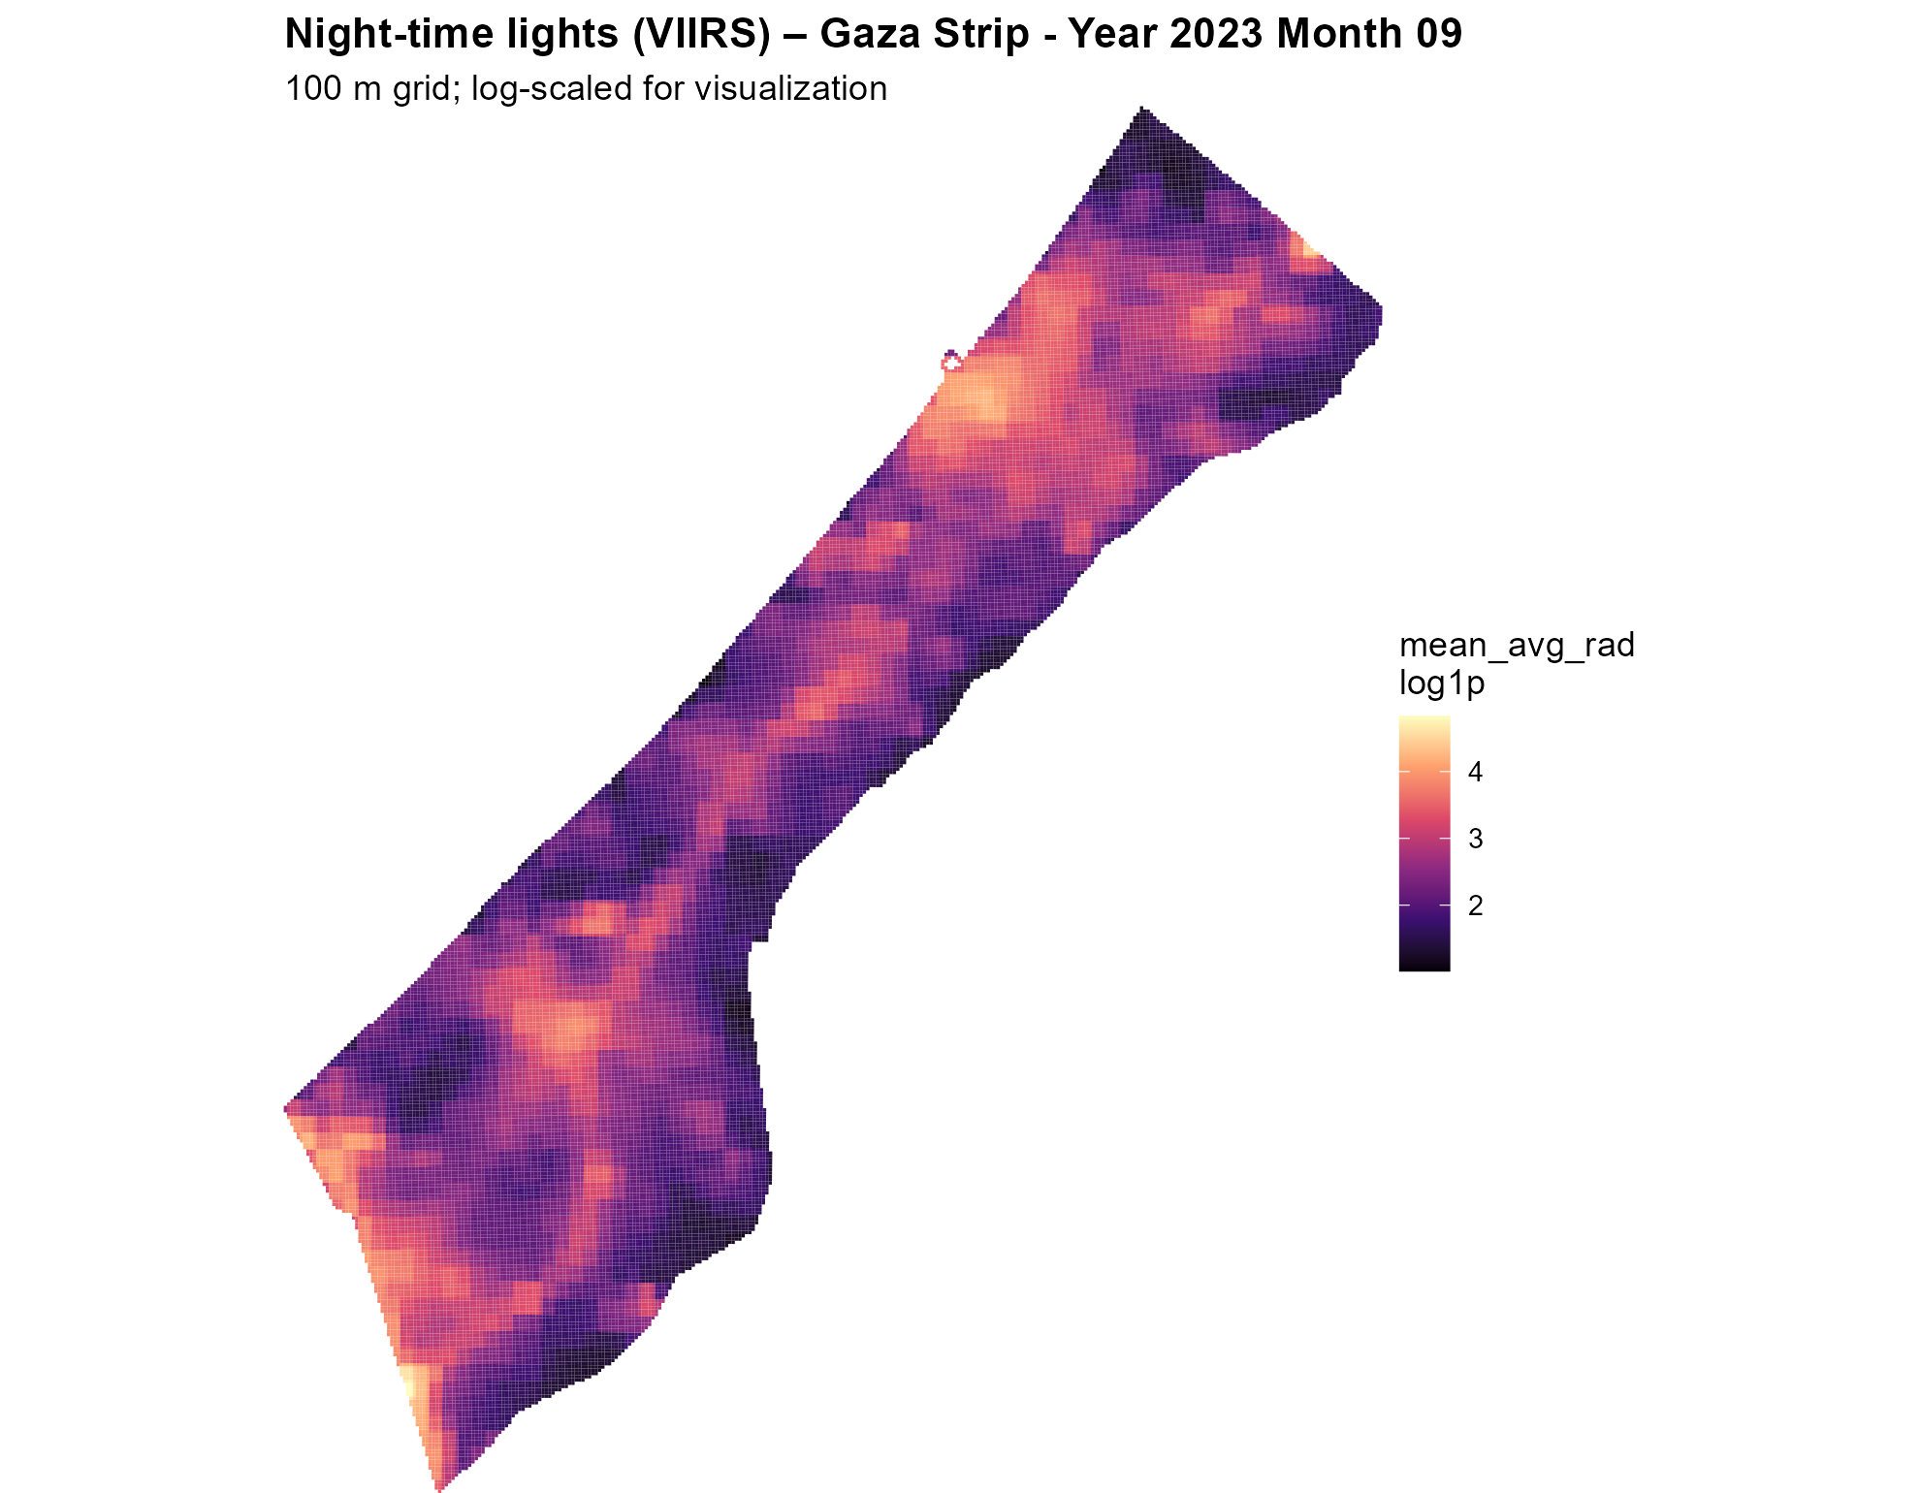
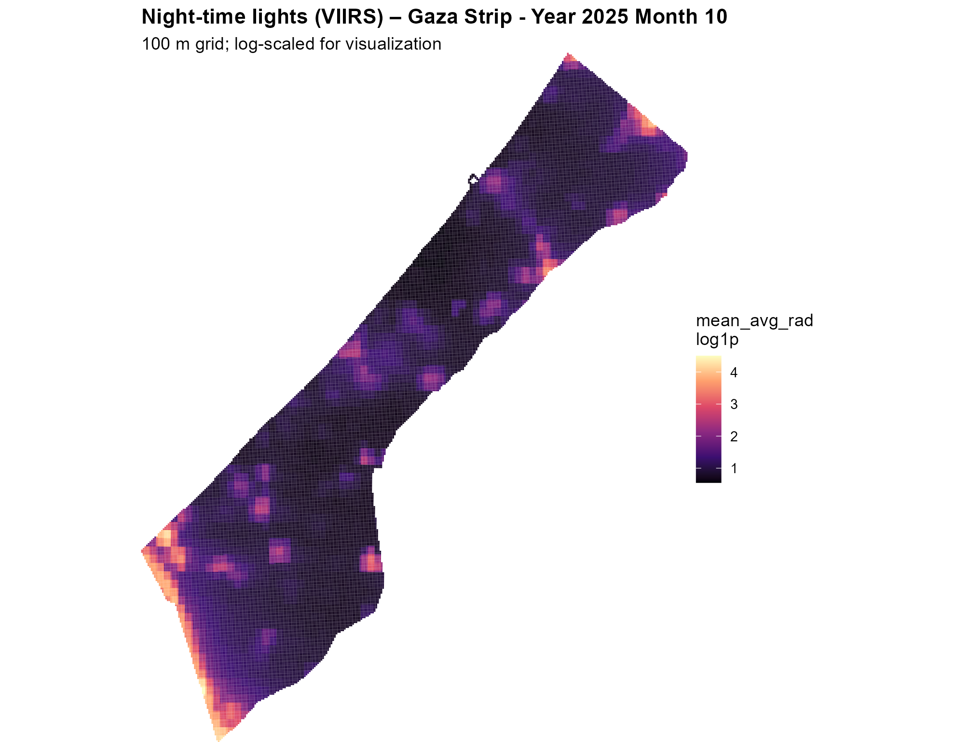

6. Dynamic Presence: Mobile Network Data & CDR Calibration
Mobile network data—specifically Call Detail Records (CDRs) and signaling data— would provide the "active" layer of the methodology. This data tracks the movement of connected individuals independently of the physical state of the buildings around them.

Calibration and Resolution Disparity
Transforming active SIM counts into estimated persons requires a rigorous calibration workflow to account for multi-SIM ownership, market share of active operators, and demographic gaps (e.g., the elderly or children without devices).
Crucially, there is a significant disparity in resolution between satellite and mobile data. According to our conceptual resolution comparison, satellite imagery (relative value 1.0) is approximately three times more granular than the cell tower signaling footprints (relative value 3.0) used in mobile data. This requires the spatial disaggregation of mobile signals across the 100m grid, proportional to the building density and radiance signals identified in previous steps.

Ethical Mandates
- Data Minimization & Anonymization: Mobile signaling data is aggregated and anonymized at the source to prevent the tracking of individuals.
- Protection Against Misuse: These probability surfaces are designed exclusively for statistical purposes.

Technical Limitations and Correctives
Several factors introduce uncertainty into the model:
- Network Outages: Power failures can make inhabited areas appear empty.
- Temporary Shelters: Standard building-detection algorithms often fail to identify tents or informal settlements.
- The corrective role of Mobile Data: Mobile signals serve as the primary corrective layer for these issues; even if a tent is invisible to satellite sensors or a building is marked as "destroyed," an active mobile signal confirms that a population is present and needs support.

Final Statement
This multi-source framework is a strategic tool for humanitarian prioritization, not surveillance. By combining the structural certainty of a 100m standardized grid with the dynamic reality of mobile signaling and VIIRS radiance, we provide an uncertainty-aware basis for protecting the most vulnerable populations in the Gaza Strip. The methodology is designed to adapt to the fluid reality of displacement, ensuring that no population remains invisible.

